**Task No. 1:** Calculate grade of each student

**Solution:**

open_file=open("data.csv",encoding="utf-8")

import csv

read_file=csv.reader(open_file)

read_file

dataset = list(read_file)

Average_Percentage=0

dataset[0].append("Obtain Marks")

dataset[0].append("Percentage")

dataset[0].append("Remark")

dataset[0].append("Grade")

for i in dataset[1:]:

chem=int(i[dataset[0].index("Chemistry")])

phy=int(i[dataset[0].index("Physics")])

math=int(i[dataset[0].index("Math")])

obtain_mark=round(chem+phy+math)

percentage=(round(obtain_mark/300*100))

Average_Percentage+=percentage

if(percentage> 50):

remark="Pass"

else:

remark="Fail"

if(percentage>80):

Grade="A+"

elif(percentage>70 and percentage<80):

Grade="A"

elif(percentage>60 and percentage<70):

Grade="B"

elif(percentage>50 and percentage<60):

Grade="C"

elif(percentage>40 and percentage<50):

Grade="D"

i.append(obtain_mark)

i.append(percentage)

i.append(remark)

i.append(Grade)

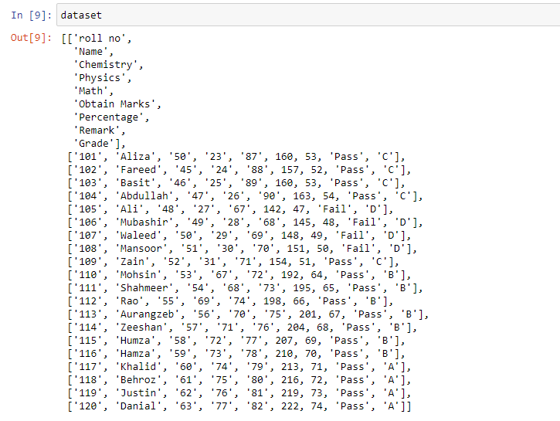**Output:**

**Task No. 2:** Calculate status of each student (Pass or Fail).

**Solution: Code is Above**

**Output:**

**Task No. 3:** Calculate number of students who have passed and failed.

**Solution:**

pass_count = 0

fail_count = 0

for row in dataset[1:]:

if row[7] == 'Pass':

pass_count += 1

else:

fail_count += 1

Total_Student_PASS_FAIL={

"PASS":pass_count,

"FAIL":fail_count,

}

print("Average Percentage ",round(Average_Percentage/len(dataset)-1,2))

Total_Student_PASS_FAIL

**Output:**



**Task No. 4:** Calculate average percentage.

**Solution:**

pass_count = 0

fail_count = 0

for row in dataset[1:]:

if row[7] == 'Pass':

pass_count += 1

else:

fail_count += 1

Total_Student_PASS_FAIL={

"PASS":pass_count,

"FAIL":fail_count,

}

print("Average Percentage ",round(Average_Percentage/len(dataset)-1,2))

Total_Student_PASS_FAIL

**Output:**

**Task No. 5:** Top three games that are popular among teens.

**Solution:**

Games=[]

for i in dataset[1:]:

if(i[dataset[0].index("prime_genre")]=='Games'):

Games.append(i[dataset[0].index("track_name")])

Games.append(i[dataset[0].index("sup_devices.num")])

Games

totalgames=[(Games[i],int(Games[i+1])) for i in range(0 ,len(Games),2 )]

totalgames

totalgames.sort(key=lambda x: x[1], reverse=True)

top_three_games = totalgames[:3]

for app, downloads in top_three_games:

print(f'{app}: {downloads} downloads')

**Output:**

**Task No. 6:** Report five most downloaded applications in social media category.

**Solution:**

Most_Downloaded=[]

for i in dataset[1:]:

if(i[dataset[0].index("prime_genre")]=='Social Networking'):

Most_Downloaded.append(i[dataset[0].index("track_name")])

Most_Downloaded.append(i[dataset[0].index("sup_devices.num")])

Most_Downloaded

app_downloads = [(Most_Downloaded[i], int(Most_Downloaded[i + 1])) for i in range(0, len(Most_Downloaded), 2)]

app_downloads.sort(key=lambda x: x[1], reverse=True)

top_five_apps = app_downloads[:5]

for app, downloads in top_five_apps:

print(f'{app}: {downloads} downloads')

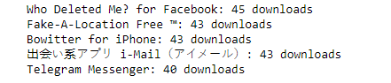**Output:**

**Task No. 7:** How many applications have never been rated.

**Solution:**

Application_Name_Not_Rating=[]

for i in dataset[1:]:

if(float(i[dataset[0].index("user_rating")])==0):

Application_Name_Not_Rating.append(i[dataset[0].index("track_name")])

Application_Name_Not_Rating

len(Application_Name_Not_Rating)

**Output:**

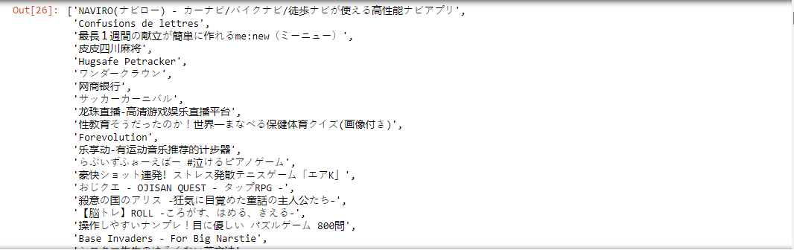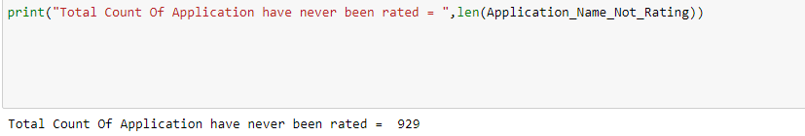

**Task No. 8:** Report top paid application of each category.

**Solution:**

categories = set()

for row in dataset:

categories.add(row[11])

for category in categories:

top_paid_app = None

for row in dataset:

if row[11] == category and row[4] != '0':

if top_paid_app is None or float(row[4]) > float(top_paid_app[4]):

top_paid_app = row

if top_paid_app is not None:

print(f'Top paid application in {category} category: {top_paid_app[1]}')

**Output:**

**Task No. 9:** Which are the top three categories famous among adults.

**Solution:**

adult_categories = []

for row in dataset:

if row[10] == '17+':

adult_categories.append(row[11])

top_adult_categories = sorted(set(adult_categories), key=lambda x: adult_categories.count(x), reverse=True)[:3]

print('Top three categories famous among adults:')

for category in top_adult_categories:

print(category)

**Output:**

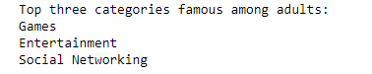

**Task No. 10:** Report all applications of "google".

**Solution:**

AllApplicationofGoogle=[]

for i in dataset[1:]:

if('Google ' in i[dataset[0].index("track_name")]):

AllApplicationofGoogle.append(i[dataset[0].index("track_name")])

AllApplicationofGoogle

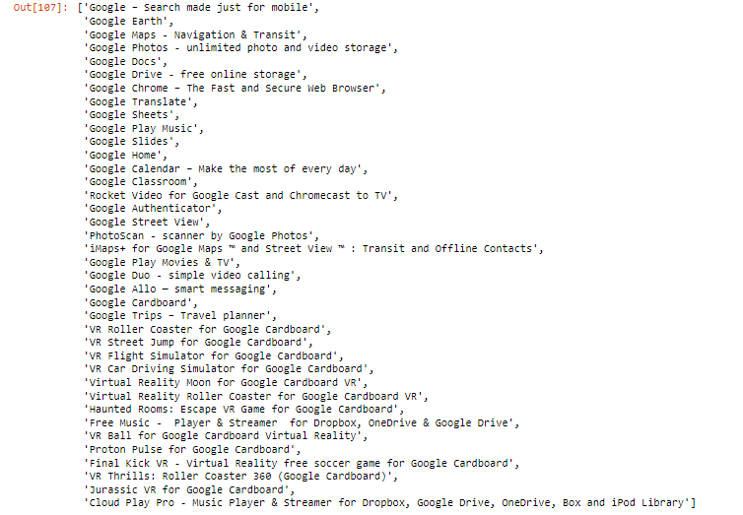**Output:**